## 

## **Experiment-7**

**Student Name:** Gauri Prabhakar **UID:** 18BCS6201

**Branch:** 18AITAIML-2 **Section/Group:** B

**Semester:** 7 **Date of Performance:** 13th October, 2021

**Subject Name:** Advanced Database Management Lab **Subject Code:** CSP - 434

# Aim/Overview of the practical:

To implement Pl/SQL programming using Exception Handling.

# Task to be done:

To implement Pl/SQL programming using Exception Handling.

# Steps to be followed:

**Implementing SYSTEM-DEFINED EXCEPTION:**

# SET SERVEROUTPUT ON;

DECLARE

X MARKS.Marks%TYPE:=&X;

STU_NAME MARKS.Name%TYPE;

BEGIN

SELECT Marks,Name INTO X,STU_NAME FROM MARKS;

DBMS_OUTPUT.PUT_LINE('Student Name:' || STU_NAME);

DBMS_OUTPUT.PUT_LINE('Student Marks:' || X);

EXCEPTION

WHEN NO_DATA_FOUND THEN

DBMS_OUTPUT.PUT_LINE('Student not found.');

WHEN OTHERS THEN

DBMS_OUTPUT.PUT_LINE('Error!');

END;

/

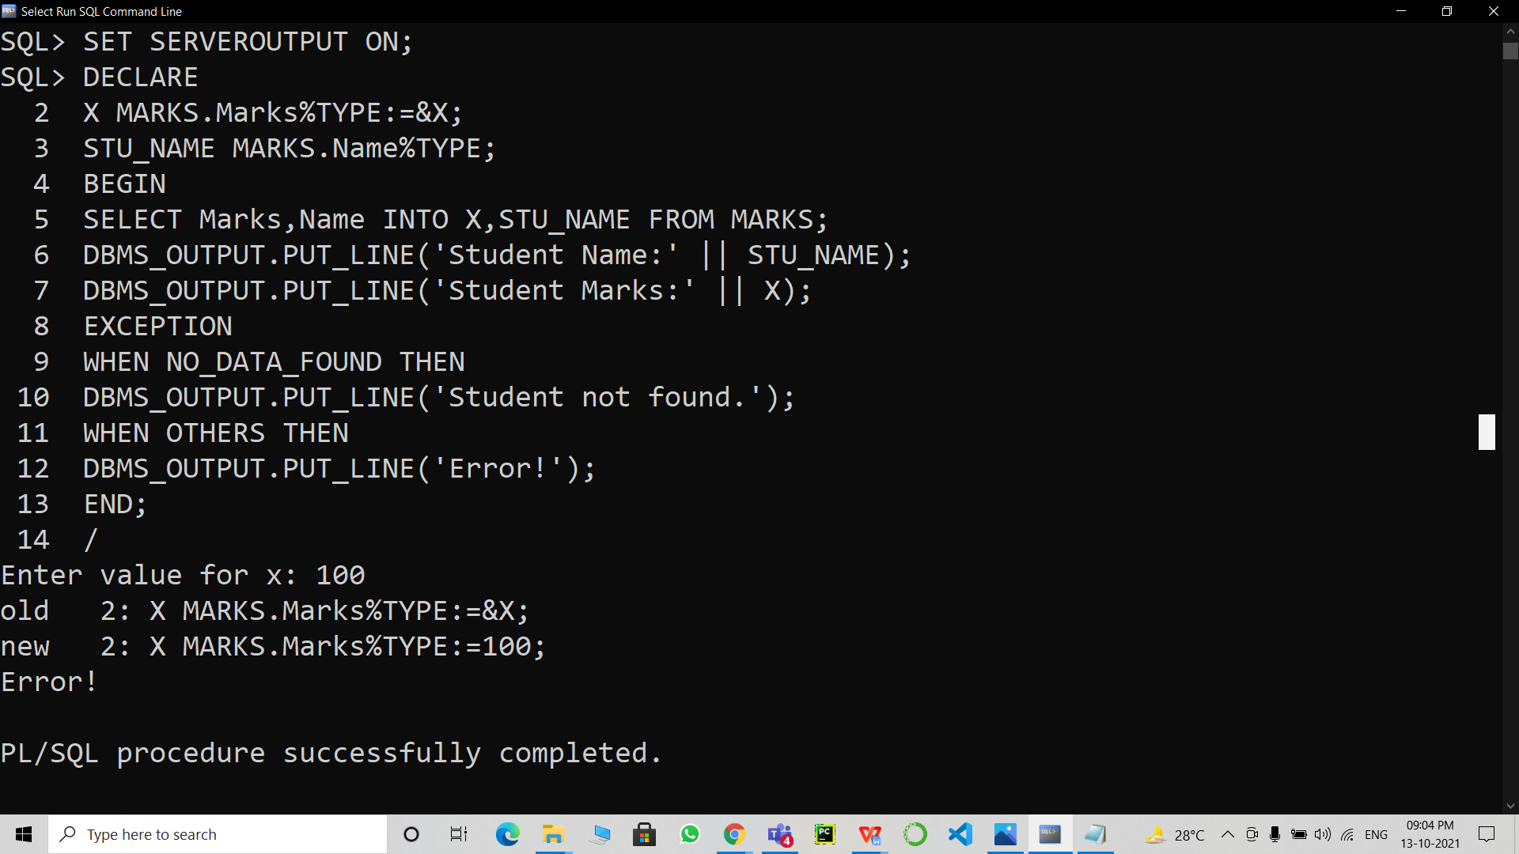

**Implementing USER-DEFINED EXCEPTION:**

1. SET SERVEROUTPUT ON;

DECLARE

AGE int:=20;

EX_INVALID_AGE EXCEPTION;

BEGIN

IF AGE<18 THEN

RAISE EX_INVALID_AGE;

ELSE

DBMS_OUTPUT.PUT_LINE('You are eligible to vote.');

END IF;

EXCEPTION

WHEN EX_INVALID_AGE THEN

DBMS_OUTPUT.PUT_LINE('You are not eligible to vote.');

END;

/

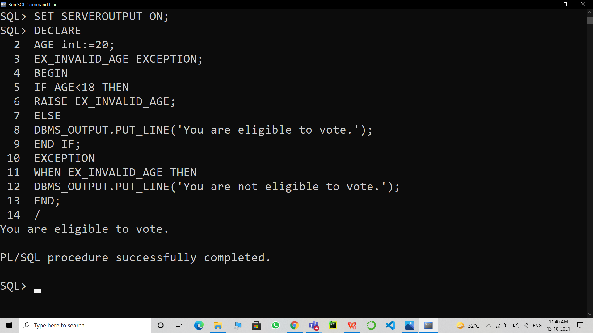

1. **Result/Output/Writing Summary:**

* Successfully implemented EXCEPTIONS.
* Successfully implemented SYSTEM-DEFINED EXCEPTIONS.
* Successfully implemented USER-DEFINED EXCEPTIONS.
* Successfully understood the functioning and importance of the above mentioned.

# Learning outcomes (What I have learnt):

* How to implement EXCEPTIONS on SQL Command Line.
* How to implement SYSTEM-DEFINED EXCEPTIONS on SQL Command Line.
* How to implement USER-DEFINED EXCEPTIONS on SQL Command Line.

**Evaluation Grid (To be created as per the SOP and Assessment guidelines by the faculty):**

|  |  |  |  |
| --- | --- | --- | --- |
| Sr. No. | Parameters | Marks Obtained | Maximum Marks |
| 1. |  |  |  |
| 2. |  |  |  |
| 3. |  |  |  |